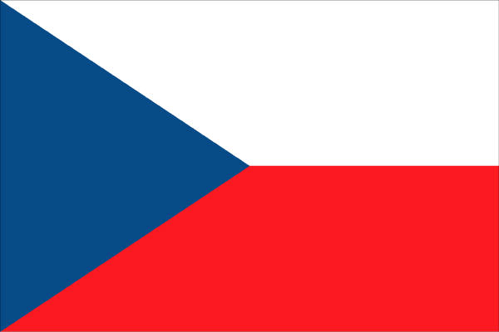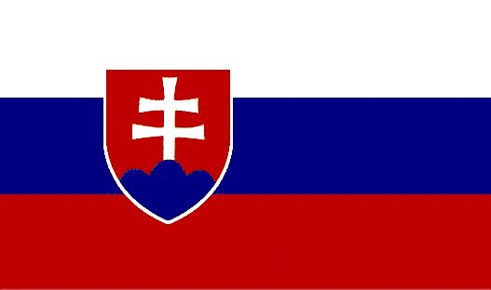
Czech – Slovak –American
Club of Tucson
Hlasatel – Newsletter – December 2009

Next meeting
Sunday, December the 13th 2009 at 1:30 p.m.
SPECIAL HOLIDAY - MIKULAS - FUNDRAISER MEETING
At our usual location: Knights of Columbus at 1330 S Mountain View.
Price: children up to 6 years: Free; 6 to 12 years: $7,-; Over 12: $15,-
Please RSVP by December 7, 2009.
Call George Coffos: 404-3255 or Vera Masa: 663-5953.
Price at the door: $18,-

Please bring items to donate for the raffle (each donated item entitles you to one free raffle ticket). Raffle tickets are $1,-/ticket.
Czech and Slovak beers will be on sale for $3,-

Announcement!
Our new Vice President elected in November meeting is Consuelo Brown.
Congratulations!

Volunteers for Setup/Cleanup Needed!!!
Volunteers are appreciated to help at the monthly meetings to set up the room as well as clean up afterwards. Please consider coming early to help and to make some new friends. We begin setting up at noon. Thanks to those that have been helping.

WHAT TO LOOK FORWARD ON December 13TH:

Holiday special Lunch Menu:
Our main dish will be Ham, Fish, special hand crafted Potato Salad, Steamed Vegetables, Italian Sausage, Fruits, Pastries, Rolls and Cake.

Entertainment:
In the spirit of an old Czechoslovakian tradition
Mikulas, Andel a Cert – St Nicholas, Angel and Devil
will visit us to listen to all children presenting their Christmas carols, reciting poems or singing songs. The Fairy Trinity will encourage the parents to share with us how were the children behaving during the year and if they deserve reward or “reward”. Bring the kids.

Special Musical Performance for Dancing, Listening and your enjoyment by our famous Bouncing Czechs.
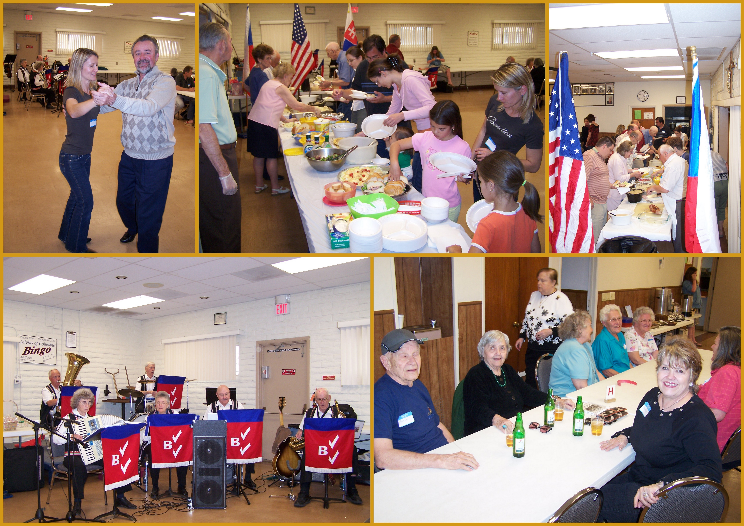

Tak pijte do polopita, So drink to be Half way Sober
Jezte do polosyta Eat to be Half way Full
At vam vyjdou naplno leta And enjoy – Life’s Not Over
…..A muzete si zatancovat …You can Dance or Jump in to the Pool
Aj jinak zaspasovat.

PAST EVENTS:

Czechoslovakian Musical Movie form 1964 “Kdyby tisic klarinetu – Thousands of Clarinets” – change of the program had to be done to show film with English subtitles.
We had a cake a listened to original pop-music of 60 ’s. And just like at home – some watched, some chatted, some slept or went for a nap. We had fun in any event.

FUTURE EVENTS:

- Next Club meeting – January program is in the works and we shall announce it soon so you can look forward to something lively.

- PPP – 4th Phoenix Pigroast Party – coming up at Jirka Hegr’s new home in Phoenix –DECEMBER 5, 2009 - “Out of this world Pig Roast” All You can Eat and All you can Drink Pilsner Urquell beer for $20,-. Live music and Czechoslovaks included. I mean it! Brush up on your Czech and Slovak conversation. After few, you will be fluent.
The Evite is out. You should have received the invitation. If not, contact us for details and directions.

(All details to be confirmed in January Newsletter and All Rights Reserved by the BOD).

Items for Sale at our Meetings:
T-shirts, revised Club Cookbooks, and Bouncing Czechs CD's are always on sale!

The Newsletter editors are interested in having more articles regarding Czechs and Slovaks and about both countries to appear in the future. We invite all Club members to submit any appropriate articles and also Ideas on improving the Club events, activities and future Club Life.

Current Board Members Board Members at Large
Petr Chylik, President Robert Wack
Consuelo Brown, Vice President Vera Masa
Linda Cerveny, Secretary Jean Coffos
George Coffos, Treasurer John Prokop
Lucia Cavallo
Address
Czech Slovak American Club of Tucson
P.O. Box 44301
Tucson, AZ 85733
Any questions? Contact us at csaclubcluboftucson@gmail.com

Prijdte se s nami potkat a pobavit.
Pevne zdravi, hodne zdaru a
kus stesti v novem roce 2010!

Come to meet us and enjoy the company.
We wish you Good Health and
Best of Luck in the year 2010!

